Let’s arbitrarily decide to mock up:

* a VxEnterprise system (to demo license functionality fully)
* named “Fort Collins VX”
* on version 3.7 (anticipated VX version that cloud will require)
* mostly healthy (no license, storage, or software & network alerts)
* 5 cameras, 4 always online, 1 going offline intermittently
  + Totally arbitrary, but most of the existing stuff goes with this number 5
* 2 recorders, both online
* 1 core node, online
* 1 media gateway node, online

To make the hardcoded content as consistent with this imaginary system as possible:

1. In VX SYSTEM DETAILS, make

* System Type = VxEnterprise
* Version = 3.7.0

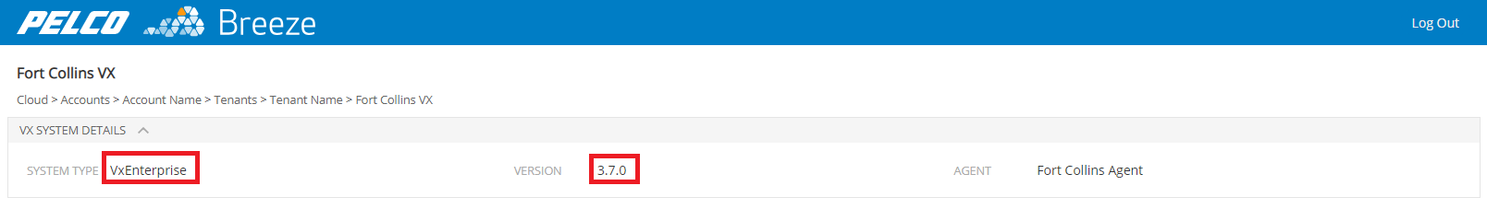

1. LICENSES area health summary should say:

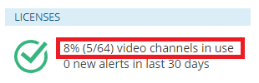

2a. Data in License Summary table should say (can cut/paste out of mockup HTML in this zip):

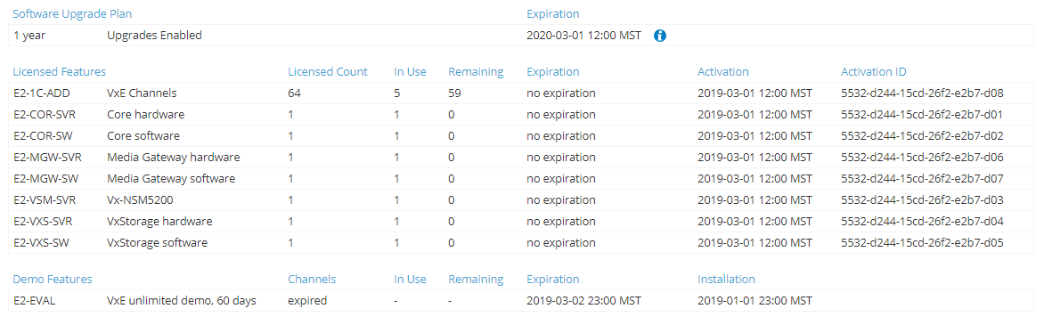

2a. Data in License Alerts table should say (can cut/paste out of mockup HTML in this zip):



1. In CAMERAS area health summary, total camera count should add up to 5.

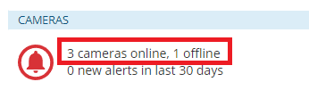

3a. Camera Summary table should have 5 cameras in it.

Camera 4 should have version 2.2.0, to match what is in Tools > Firmware Updater.

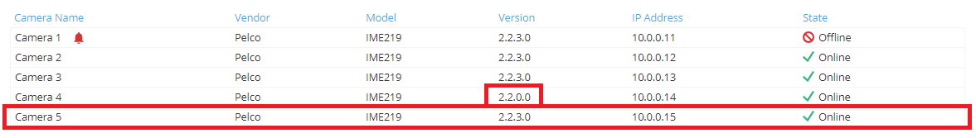

1. In STORAGE section:

4a. Storage Summary table should only have 2 recorders in it (can cut/paste out of mockup HTML in this zip). Somehow there are currently 11 listed on cloud-dev. 😊

* Also, on cloud-dev this table appears to have incorrect class “licenses-alerts-table” applied to it, which is making the first column bunched up.

For this table, class="compact-list storage-summary-table".

* Also add unit “(GB)” to the Total Space column header.
* And change VxS version to “3.7.0”, to match imaginary system version.



4b. Storage Alerts table should have 0 alerts.

* Also, on cloud-dev this table appears to have incorrect class “licenses-alerts-table” applied to it. Not a big deal, since all alerts tables are currently styled the same, but semantically incorrect and could cause trouble in the future.

For this table, class="compact-list storage-alerts-table".



1. SOFTWARE & NETWORK area health summary should say “0 offline”.

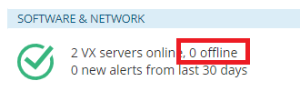

5a. Make Servers Summary table match our imaginary system data.

* Also, on cloud-dev this table appears to have incorrect class “licenses-alerts-table” applied to it, which is making the first column bunched up.

For this table, class="compact-list servers-summary-table".



5b. System Alerts table should have 0 alerts.

* Also, on cloud-dev this table appears to have incorrect class “licenses-alerts-table” applied to it. Not a big deal, since all alerts tables are currently styled the same, but semantically incorrect and could cause trouble in the future.

For this table, class="compact-list system-alerts-table".

